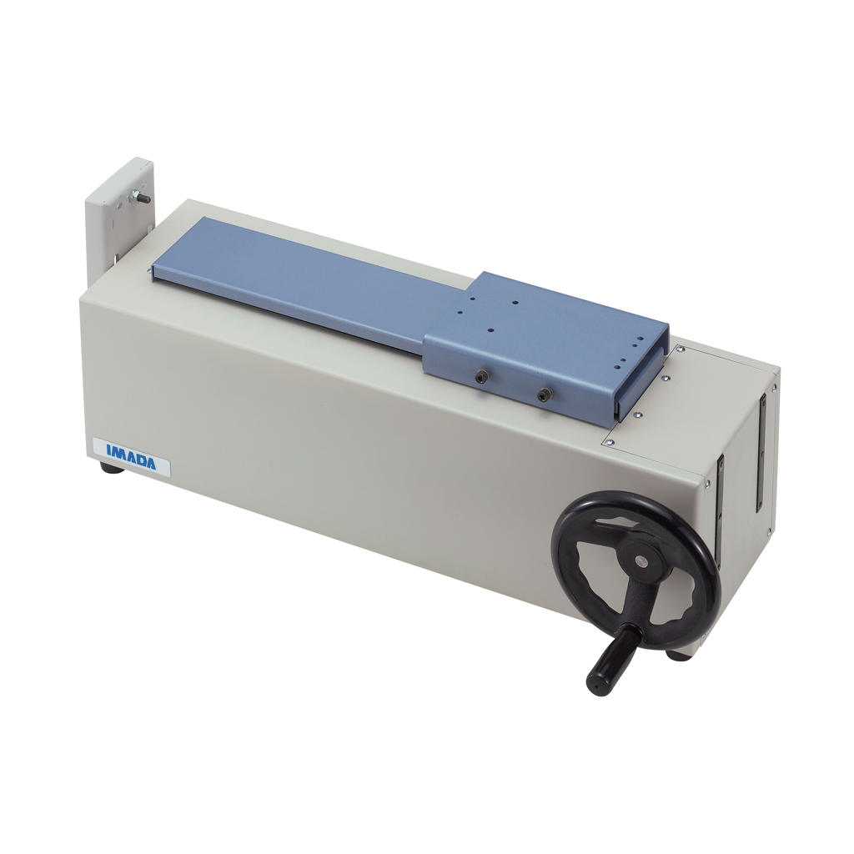

SH Series Specifications

Model | Capacity | Stroke | Travel/Rotation
SH-110 or SH-110-S | 110 lbf | - | -
SH-220 or SH-220-S | 220 lbf | 11.8" (300mm) | 1.2mm
SH-750 or SH-750-S | 750 lbf | 14.5" (370mm) | 0.6mm

Standard Distance Meter Specifications
Display | Push button for inch/mm, zero set and on/off
Resolution | 0.0005"/0.01 mm
Accuracy | 0.1% of reading or 0.005"/0.1 mm whichever is greater

